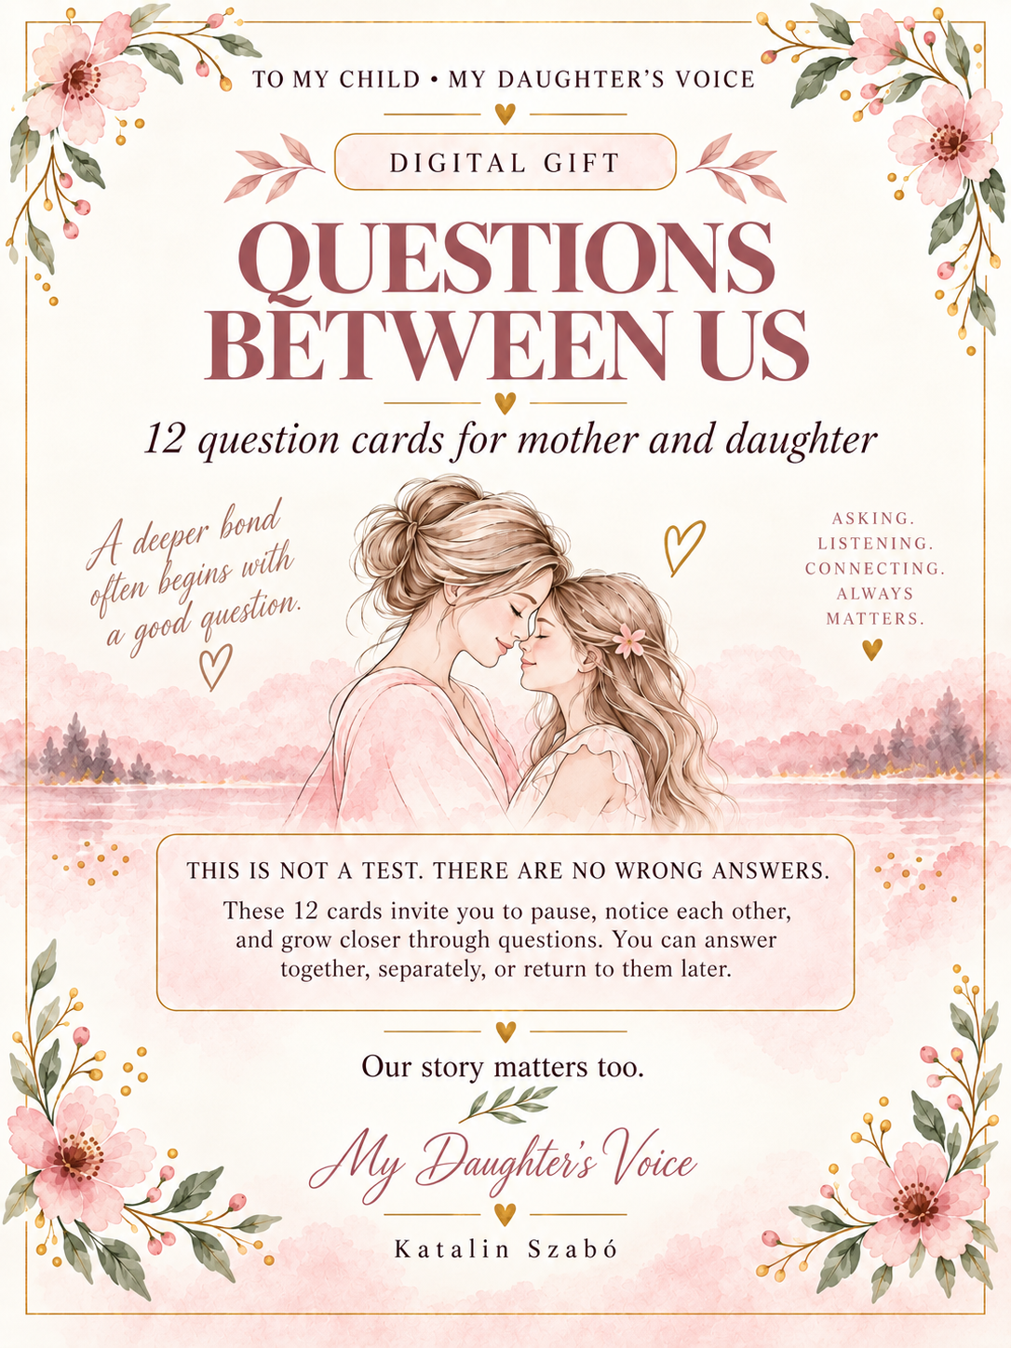

TO MY CHILD • MY DAUGHTER’S VOICE
— ♥ —
CARD 1
WHAT MATTERS TO ME RIGHT NOW
— ♥ —
What has been on your heart lately—something that brings you joy, or something that feels hard?
Write your answer here…
— ♥ —
Your voice matters.
Closer to each other, one question at a time.
Katalin Szabó

TO MY CHILD • MY DAUGHTER’S VOICE
— ♥ —
CARD 2
WHAT I WISH YOU KNEW
— ♥ —
Is there something you wish I understood about you better? Something important you would like to share with me?
Write your answer here…
— ♥ —
Honesty brings us closer.
Closer to each other, one question at a time.
Katalin Szabó

TO MY CHILD • MY DAUGHTER’S VOICE
— ♥ —
CARD 3
A MEMORY WE SHARE
— ♥ —
Which shared memory warms your heart the most, and why does that moment stay with you?
Write your answer here…
— ♥ —
Memories connect us.
Closer to each other, one question at a time.
Katalin Szabó

TO MY CHILD • MY DAUGHTER’S VOICE
— ♥ —
CARD 4
WHAT I’M PROUD OF
— ♥ —
What is one quality in yourself that you feel most proud of today?
Write your answer here…
— ♥ —
The way you see yourself matters.
Closer to each other, one question at a time.
Katalin Szabó

TO MY CHILD • MY DAUGHTER’S VOICE
— ♥ —
CARD 5
WHEN I NEED SUPPORT
— ♥ —
Where would my support help you most right now? What would truly feel supportive?
Write your answer here…
— ♥ —
Support can begin with attention.
Closer to each other, one question at a time.
Katalin Szabó

TO MY CHILD • MY DAUGHTER’S VOICE
— ♥ —
CARD 6
WHAT I WOULD CARRY FORWARD
— ♥ —
What would you like to carry forward from our relationship or from home into your own life?
Write your answer here…
— ♥ —
Love can also be an inheritance.
Closer to each other, one question at a time.
Katalin Szabó

TO MY CHILD • MY DAUGHTER’S VOICE
— ♥ —
CARD 7
WHAT GIVES YOU STRENGTH
— ♥ —
What has been giving you the most strength lately on the more difficult days?
Write your answer here…
— ♥ —
Strength is often built from small things.
Closer to each other, one question at a time.
Katalin Szabó

TO MY CHILD • MY DAUGHTER’S VOICE
— ♥ —
CARD 8
A QUESTION FOR MOM
— ♥ —
Is there a question you would like to ask me honestly right now?
Write your answer here…
— ♥ —
Questions can bring us closer.
Closer to each other, one question at a time.
Katalin Szabó

TO MY CHILD • MY DAUGHTER’S VOICE
— ♥ —
CARD 9
WHAT I WOULD THANK YOU FOR
— ♥ —
What is something you would most like to thank me for today?
Write your answer here…
— ♥ —
Gratitude spoken aloud can bring us closer.
Closer to each other, one question at a time.
Katalin Szabó

TO MY CHILD • MY DAUGHTER’S VOICE
— ♥ —
CARD 10
WHERE YOU ARE RIGHT NOW
— ♥ —
How do you feel in your life right now, and where would you like to move forward?
Write your answer here…
— ♥ —
Your present is also an important story.
Closer to each other, one question at a time.
Katalin Szabó

TO MY CHILD • MY DAUGHTER’S VOICE
— ♥ —
CARD 11
WHAT I WANT YOU TO KNOW
— ♥ —
What message would you like me to always carry with me from you?
Write your answer here…
— ♥ —
Some sentences stay with us.
Closer to each other, one question at a time.
Katalin Szabó

TO MY CHILD • MY DAUGHTER’S VOICE
— ♥ —
CARD 12
TOWARD THE FUTURE
— ♥ —
What kind of relationship would you like us to have in the future, and what would help us build it?
Write your answer here…
— ♥ —
Our relationship can keep growing.
Closer to each other, one question at a time.
Katalin Szabó

